C# - Func

We have learned in the previous section, that a [delegates](http://www.tutorialsteacher.com/csharp/csharp-delegates) can be defined as shown below.

Example: C# Delegate

public delegate int SomeOperation(int i, int j);

class Program

{

static int Sum(int x, int y)

{

return x + y;

}

static void Main(string[] args)

{

SomeOperation add = Sum;

int result = add(10, 10);

Console.WriteLine(result);

}

}

Output:

20

C# 3.0 includes built-in generic delegate types Func and Action, so that you don't need to define custom delegates as above.

Func is a generic delegate included in the System namespace. It has zero or more *input* parameters and one *out* parameter. The last parameter is considered as an out parameter.

For example, a Func delegate that takes one input parameter and one out parameter is defined in the System namespace as below:

Signature: Func

namespace System

{

public delegate TResult Func<in T, out TResult>(T arg);

}

The last parameter in the angle brackets <> is considered as the return type and remaining parameters are considered as input parameter types as shown in the following figure.

[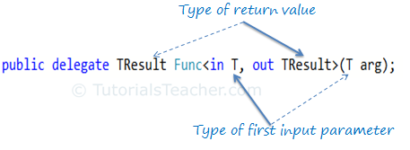](http://www.tutorialsteacher.com/Content/images/csharp/func-delegate.png)Func delegate

A Func delegate with two input parameters and one out parameters will be represent as below.

[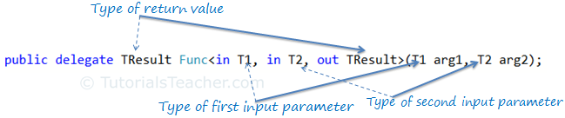](http://www.tutorialsteacher.com/Content/images/csharp/func-delegate2.png)Func delegate

The following Func type delegate is the same as the above SomeOperation delegate, where it takes two input parameters of int type and returns a value of int type:

Func<int, int, int> sum;

You can assign any method to the above func delegate that takes two *int* parameters and returns an *int* value. Now, you can take Func delegate instead of someOperation delegate in the first example.

Example: Func

class Program

{

static int Sum(int x, int y)

{

return x + y;

}

static void Main(string[] args)

{

Func<int,int, int> add = Sum;

int result = add(10, 10);

Console.WriteLine(result);

}

}

Output:

20

A Func delegate type can include 0 to 16 input parameters of different types. However, it must include one out parameter for result. For example, the following func delegate doesn't have any input parameter, it includes only a out parameter.

Example: Func with Zero Input Parameter

Func<int> getRandomNumber;

C# Func with an Anonymous Method

You can assign an anonymous method to the Func delegate by using the delegate keyword.

Example: Func with Anonymous Method

Func<int> getRandomNumber = delegate()

{

Random rnd = new Random();

return rnd.Next(1, 100);

};

Func with Lambda Expression

A Func delegate can also be used with a lambda expression, as shown below:

Example: Func with lambda expression

Func<int> getRandomNumber = () => new Random().Next(1, 100);

//Or

Func<int, int, int> Sum = (x, y) => x + y;

 Points to Remember :

1. Func is built-in delegate type.
2. Func delegate type must return a value.
3. Func delegate type can have zero to 16 input parameters.
4. Func delegate does not allow ref and out parameters.
5. Func delegate type can be used with an [anonymous method](http://www.tutorialsteacher.com/csharp/csharp-anonymous-method) or [lambda expression](http://www.tutorialsteacher.com/linq/linq-lambda-expression).